(Approx. 632 words)

Cannot Send Mail - A copy has been placed in your Outbox
By Hewie Poplock, Director APCUG
Vice President, Central Florida Computer Society
Hewie's Views & Reviews, http://www.hewie.net

I was excited to be able to upgrade my iPad2 to the new iOS5. The upgrade went well, and it was a day or 2 before I realized that I was having email issues. My default account changed to an AT&T address. When I changed it back to my main email account I got the following error message:
.
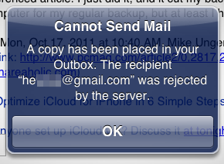

"Cannot Send Mail. A copy has been placed in your Outbox. The recipient xxxxx@xxxxx.com was rejected by the server"

I did some searching and found that I might have to change some settings. In the end, I discovered that of the 39 email accounts that I check, those that were not Gmail accounts could not send email. All were able to receive mail, however. After searching and checking my settings, I realized that during the iOS upgrade, the accounts were all reinstalled, but the settings either disappeared or changed.

I had to go to the "Mail, Contacts, Calendars" setting and go individually through each of my accounts. I checked the settings, corrected them, and then tested each account. It was time consuming, but once I finished, I changed my default account back to my main account and can was able to send & receive using all 39 accounts.

When I found some suggestions on how to fix the problem, all of the forums left out at least 1 critical step, so it took a while to determine the correct settings and where they were. What I show below may not be true for your accounts, but most of my accounts are on GoDaddy and this worked for me.

First I chose 1 account from the list.

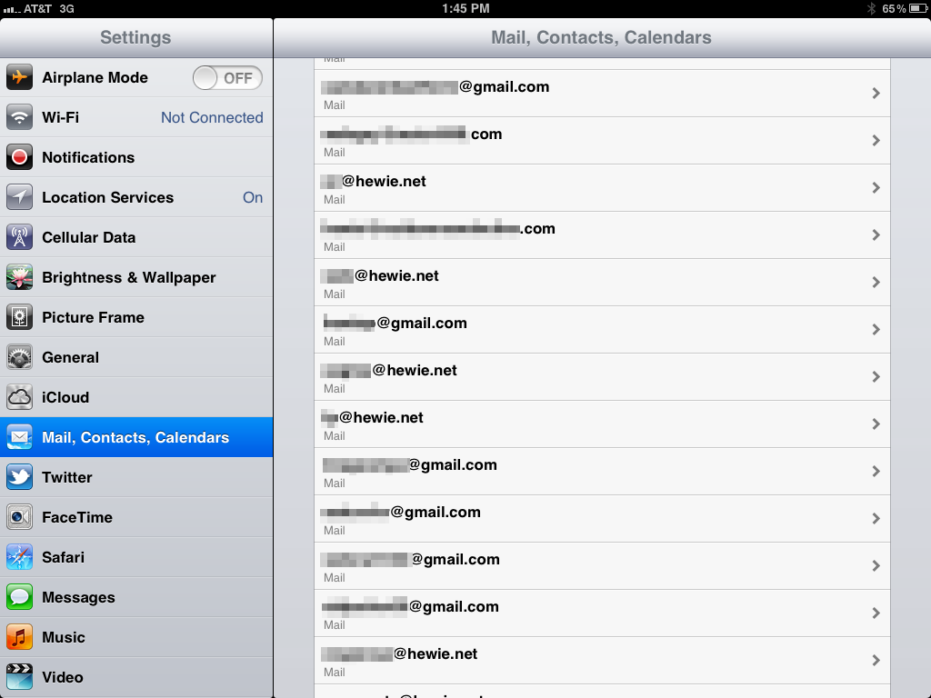

Then I made sure that all of the info was correct on that screen. I then clicked on "Advanced." I do not use SSL and the port 110. I had to make sure that Authentication was set at "Password."

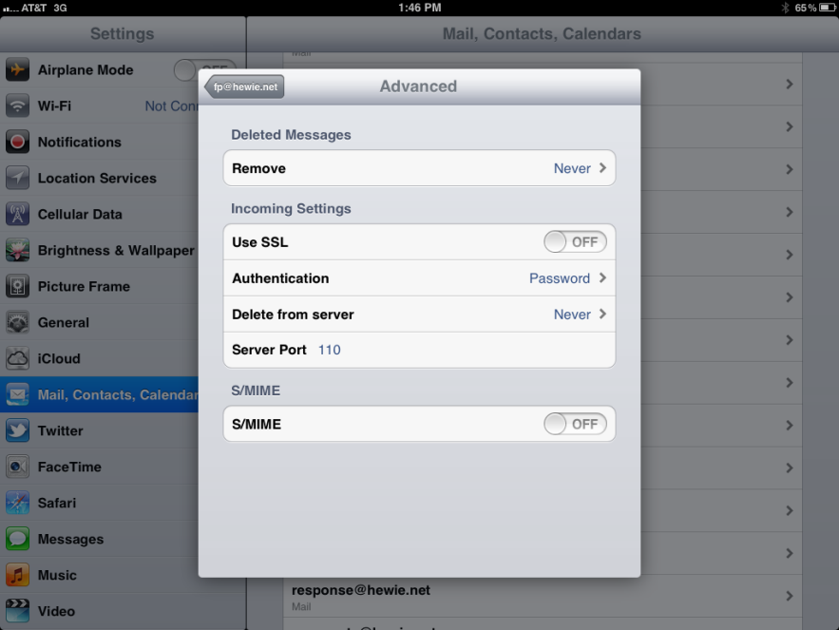

Then I went back and clicked on SMTP.

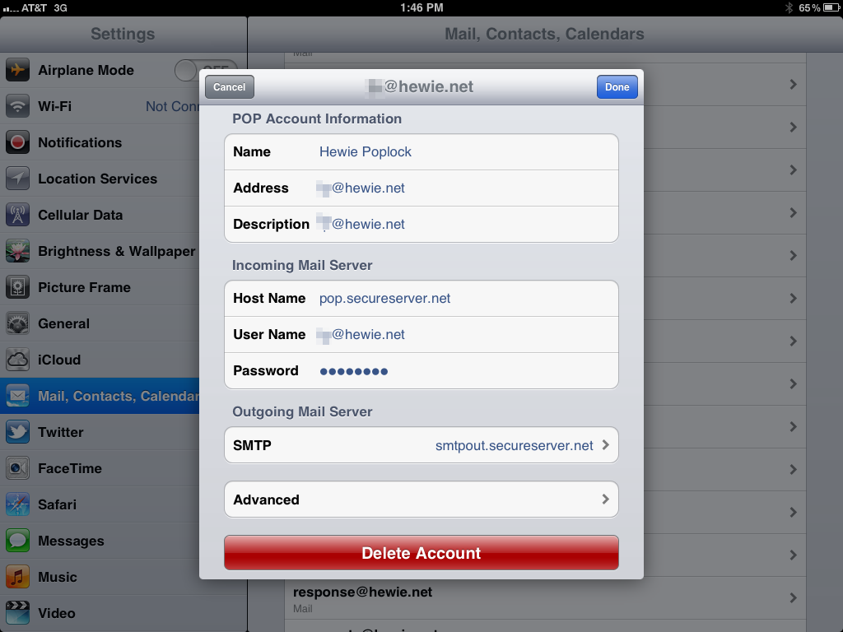

In some cases, The Primary Server was set "On", but I found out if I set it to "Off" and clicked on it, I got the dialog box that I needed. This was the step left out in descriptions that I found on line. Then I was able to get to the Outgoing Mail Server dialog box.

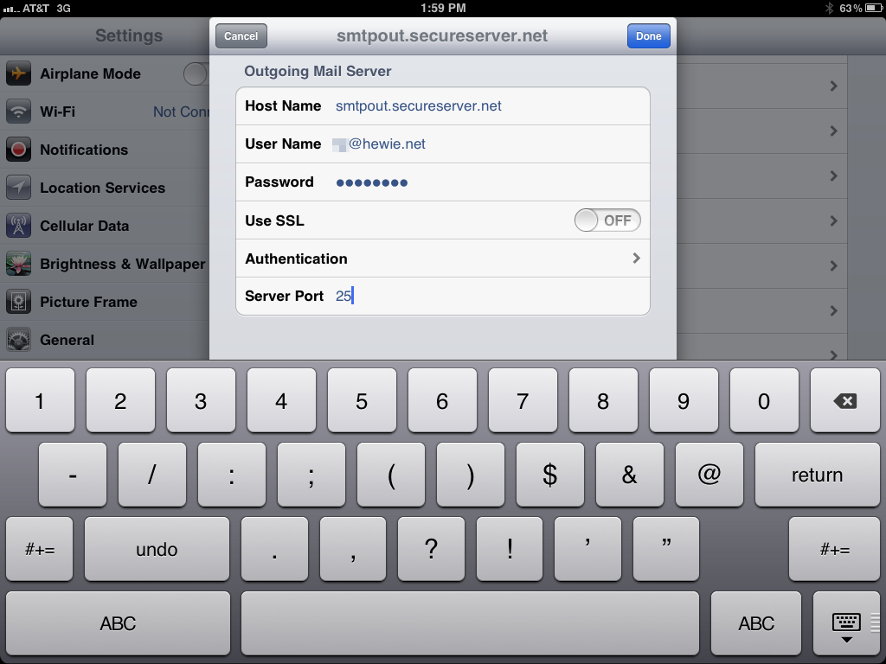

In most cases I had to fill in the User Name and Password, I also had to correct the Server Port. I then clicked on Authentication to make sure that it was set to Password.

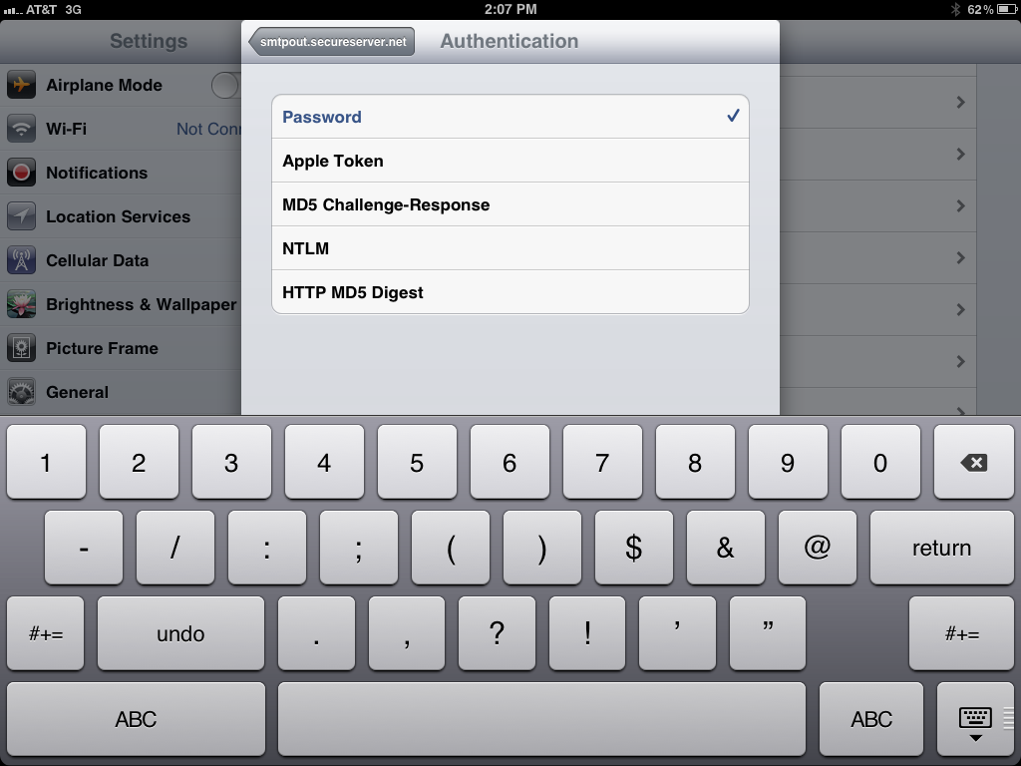

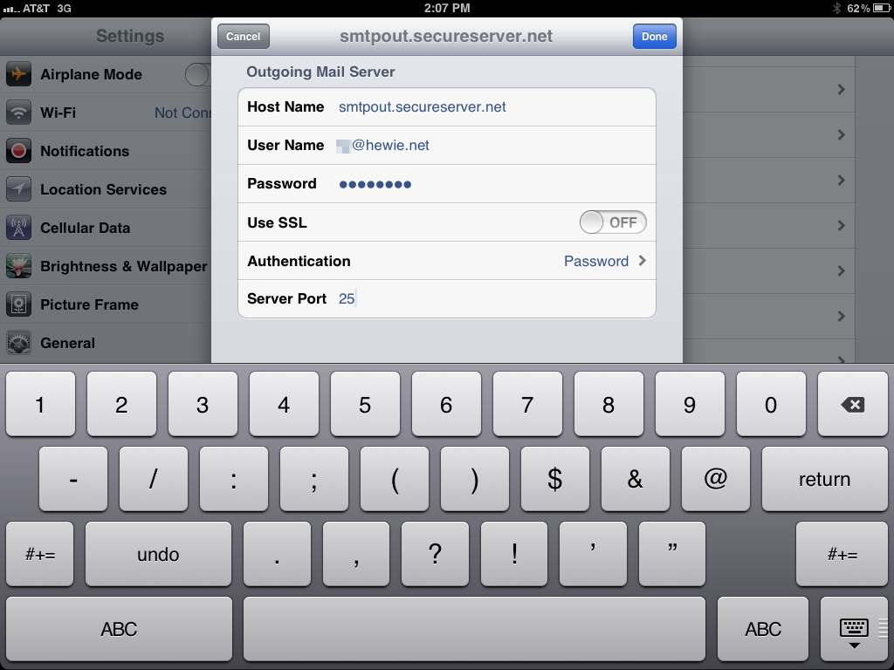

I then made sure that the Primary Server was turned back on.

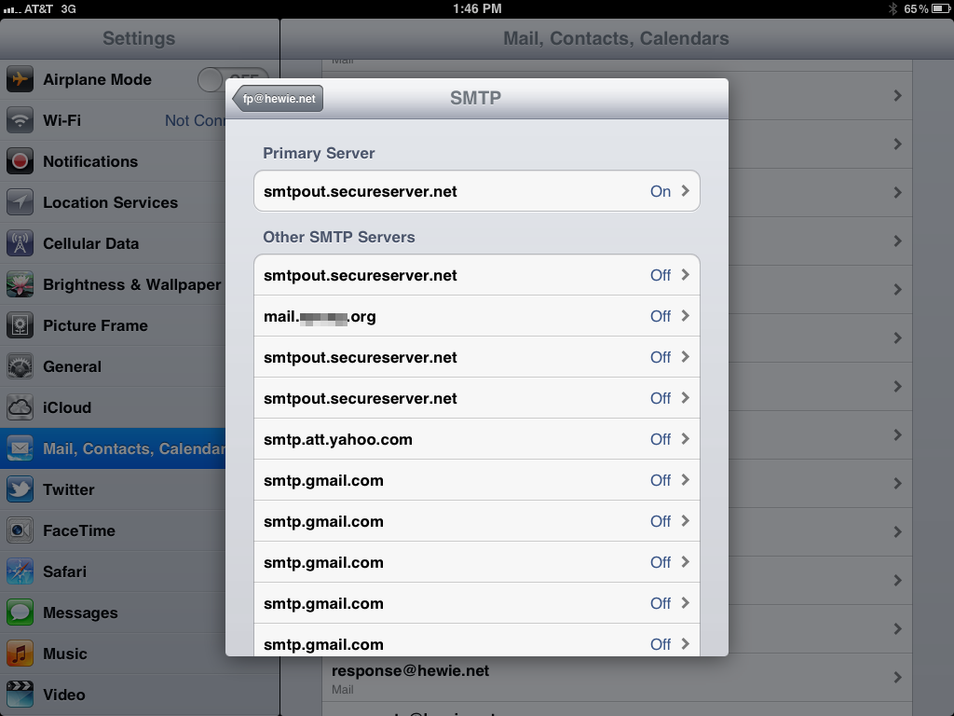

Once I clicked on Done, the system wanted to verify my settings and this took from 3 to 9 minutes each time. If it did not verify because I didn't get the setting right, I had to make the changes again and then wait once again for verification.

I double checked all of the settings and then tested by sending a message to one of my Gmail accounts and CC'ed the account I was testing. If I got two messages, one for each of the accounts in the message, I knew that it worked, and I went to the next account. If not I went back to discover which setting I missed.

Once I had all of the accounts working, I changed my default account and all was fine. Two weeks later my new iPhone 4s arrived to replace my original iPhone. As I expected, I had to repeat the above exercise on the new phone. Needless to say, it was time-consuming and tedious, but now both, the iPad2 and the iPhone4s are handling all of my emails.

